**Richland Parish Communications District**

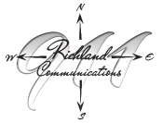

**Administrator: Beth Lewis President: Kenneth Hall**

**Secretary: Joshua Strickland Treasurer: Rebecca Hillman**

**708 Julia St Suite B103C Rayville, La 71269 - Phone: 318-728-2233 - Fax:318-728-2223 - Email: rpcd@richland911.org**

**Agenda-May 15, 2025**

**Special Meeting**

**Meeting place:** Richland Parish Courthouse 911 Office Lobby

708 Julia Street, Suite B103, Rayville, La 71269

**Meeting time:** 5:30 PM

* 1. Open with prayer
  2. Roll call
  3. Approve Agenda

**New Business**

1. 911 Wireless Surcharge